A

Project Report

On

**GAS AGENCY MANAGEMENT SYSTEM**



**R. C. Patel Educational Trust’s**

**R. C. Patel Arts, Commerce, Science College, Shirpur**

**Submitted By**

**Purohit Chetan Keshav**

E-Mail:-chetan721k@gmail.com

PRN NO:-2016015400349262

**Guided By**

**Submitted To**

Kavayitri Bahinabai Chaudhari North Maharashtra University, Jalgaon.

2018-2019

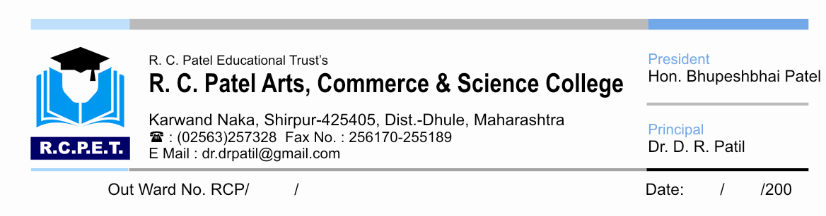

**CERTIFICATE**

This is to certify that this field work report on “***Gas Agency Management System*”** inembodies the original work done by **Purohit Chetan Keshav** during this project report submission as a partial fulfillment of the requirement for the in academic year 2018-2019 as a part of **T.Y.B.C.A.** Sem-VI under the K.B.C.North Maharashtra University, Jalgaon.

**Guided By Head of Computer Application**

**Mr. Sandip P.Patil**

**Internal Examiner External Examiner**

**A**

**Project Report**

**On**

**“Gas Agency Management System”**

**For**

Organization Name **:** **Rajsagar Bharatgas, Shirpur**

Course Name **:** **Bachelor of Computer Application (BCA)**

Class **:** **T.Y.B.C.A.**

Name of Student **:** **Chetan Keshav Purohit**

E-mail id of Student **:** [**chetan721k@gmail.com**](mailto:chetan721k@gmail.com)

Mobile no. of Student **:** **9145470021**

College Name **:** **R.C. Patel Arts, Commerce and Science**

**College, Shirpur, Dhule**

College **:** **240051**

Academic Year **:** **2018-19**

Project Guide Name **:**

Mobile No. of Guide **:**

E-mail id of Guide **:**

**ACKNOWLEDGEMENT**

I feel great pleasure in submitting Project Report on “***Gas Agency Management System***”. I wish to explore true sense of gratitude towards our Project Report guide **Mrs. --------**, who act very discrete step to solve every problem that arise. My great obligation would remain towards **Mr. Sandip P. Patil (Head of Computer Application),** who was a constant inspiration during my Project Report. He provided with an opportunity to undertake the Project Report at **R.C. Patel ACS College, Shirpur**.

I feel highly indebted to them who provided us with our entire project requirement and done much beyond our expectation to bring out the best in us. My sincere thanks to **Principal Dr. D.R. Patil** proved to be constant motivation for the knowledge acquisition and moral support during our course curriculum. Last but not the least. I am thankful to those who have directly and indirectly helped in presentation of this Project Report.

**Chetan Keshav Purohit**

**GAS AGENCY MANAGEMENT SYSTEM**

Date: / /2019

**CERTIFICATE**

This is to certify that **CHETAN KESHAV PUROHIT** student of T.Y.BCA has completed his project work entitled **“Gas Agency Management System”** organization. We found all our requirement and necessities are satisfied in a very well manner and efficient way. We realize that our work will become easier and accuracy will be increased.

**RAJSAGAR BHARTAGAS**

|  |  |  |
| --- | --- | --- |
| **Chapter No** | **Name of Chapter** | **Page No.** |
| 1 | **Introduction** |  |
|  | 1.1 Introduction to project |  |
|  | 1.2 Objective of Project |  |
|  | 1.3 Scope of Project |  |
| 2 | **System Study And Analysis** |  |
|  | 2.1 Information gathering |  |
|  | 2.2 Existing System |  |
|  | 2.3 Drawbacks in existing system |  |
| 3 | **Need Of Computer** |  |
|  | 3.1 Need for System |  |
|  | 3.2 Need for Computerization |  |
|  | 3.3 Advantages of Computerization |  |
|  | 3.4 Introduction of Proposed computerization System |  |
|  | 3.5 Advantages of computerized system |  |
|  | 3.6 System security |  |
| 4 | **Feasibility Study** |  |
|  | 4.1 Economical Feasibility |  |
|  | 4.2 Technical Feasibility |  |
|  | 4.3 Operational feasibility |  |
| 5 | **Hardware/software Requirement** |  |
| 6 | **Reason for selecting VB.NET** |  |
| 7 | **Preliminary Design for proposed system** |  |
|  | 7.1 Data designing |  |
|  | 7.2Input designing |  |
|  | 7.3 Output designing |  |
|  | 7.4 Screen designing |  |
|  | 7.5 Procedural designing |  |
|  | 7.6 Architectural designing |  |
| 8 | **Detail design of proposed system** |  |
|  | 8.1 Detail designing |  |
|  | 8.2 Data dictionary |  |
| 9 | **Appendix A** |  |
|  | 9.1 Data Entry screens as forms |  |
| 10 | **Appendix B** |  |
|  | 10.1 Sample reports generated by computerized system |  |
| 11 | **Conclusion** |  |
| 12 | **Reference** |  |

**INDEX**

**Chapter no: - 1**

**Introduction**

**1.1 Introduction to project:**

Rajsagar Bharat Gas, Shirpur.

The “Rajsagar Bharat Gas” is situated in Shirpur Tal. Shirpur dist. Dhule. It was running since last 12 years. The leader this Cylinder is Mr. ------- there is not particular quota fixed by the company or the agency who provides Gas cylinder. A dealer purchase main item in Gas.

**1.2 Objective of project:**

The main objective of this system is to reduce the consumption of time during maintaining the records of Gas Management. Separate divisions are provide to maintain the records of item, supplier, stock, order, purchase and sales details.

In other words, our Gas Management System has, following objectives

* Simple database is maintained.
* Easy operations for the operator of the system.
* Under interfaces are user friendly and attractive; it takes very less time for the operator to get use to with the system.

**1.3 Scope of project:**

This is generic type of software, suitable for all Gas Cylinder dealer. It has separate divisions to handle the Gas Cylinder transaction. Separate division is provided to maintain supplier records, Stock Records, Sales Records, Purchase Records, and order Records.

**Chapter No: -2**

**System Study and Analysis**

**2.1 Information gathering:**

Investigation of system is first step while designing a system. This is the way to handle user’s needs.

We consider following things:-

1. How the precise system works?
2. Time taken to process the data through system.
3. List of documents.
4. Files, reports associated with system.

From the available document we got basic idea about fundamental of system as well as input and output of this system. In next step we have about existing system and collected information about inputs, reports, transaction.

**2.2 Existing system:**

Before developing the computerized system the firm managed the work manually in different modes i.e. work was divided into various steps.

These steps were as follow:-

1. Manual calculation of cylinder.
2. Manage customer information from whom they purchase cylinder whom they sells woods.
3. After this, make bill to the customer who purchases the cylinder.
4. All the trading maintain manually.

**2.3 Drawbacks of existing system:**

1. Accuracy is less because all work in done manually.
2. More time is required for data entry its does not avoid repetitions of data entry.
3. More time is required to process required information in form of output, hence reports required for management getting developed.
4. Human mistakes may be possible.
5. Handling of all records and different files is tedious and lengthy jobs.
6. It requires experience and trained person to look after a particular job.
7. Less statistical accuracy.

**Chapter No: -3**

**Need of computer**

**3.1 Need of system:**

**3.2 Need for computerization:**

The main aim of the computerizing any system is to provide less time, less Work, to increase efficiency and according so that large task can be done in short period of time.

The computer is use to assist the main in business organization carry out large and wide variety of activity. Accurate recording and processing of this activity are called as data processing. As the complexity and size of the organization is growing day by day, some degree this automation becomes necessary.

When organization grows the manual system begin to break down, thus harming task of planning and controlling. In most of the organization electrical cost low and increase efficiency was introduce for processing of various transaction that arrives in difficult organization operation.

Most organization carry out largest wide variety of business transaction, accurate recording and processing of this transaction is now as data processing. Today some degree of automation exists in all organization in degree and processing of daily transaction.

**3.3 Advantages of computerization:**

Business organization found that they could computerize the transaction processing tasks quickly by using standard software:

The major advantages of such standard software.

1. Improved accuracy is more than manual system.
2. All calculation is done externally so calculation solved within a second.
3. Processing time of information is negligible.
4. Simple handling and retrieving of data is very easy.
5. Data entry time is negligible as compared to manual system while entering customer’s entries previous data will be reduced.
6. Easy for any type of search record.

**3.4 Introduction to proposed system:**

Our computerized system is specially design for petrol cylinder management which is made exactly as per the need of the organization. It is designed to speed up activity in the existing system and to minimized the human error, man power and optimized its cost with better accuracy

The system is made very simple to understand and operate. This system supports the

Graphical User Interface because this is menu driven and every time short keys are used to works through the keyboard also.

The system takes the data of item, Cylinder, order, purchase, sales, stock, suppliers input. The system generate reports as follows:

* + Supplier report
  + Stock report
  + Sales report
  + Purchase report
  + Order report

In our proposed system we have the provision for adding the details of the Cylinder management. Another advantage of the system is that it is very easy to edit the details of the supplier and delete a supplier when it found unnecessary. Here is no facility of net connection, email facility is also not provided. Online payment is not possible.

By developing the system, we can attain the following facilities:

* Easy to handle and feasible.
* Easy to operate.
* Cost reduction.
* Fast and convenient.

**3.5 Advantages of computerized system:**

* Accuracy is more than manual system.
* Data entry time is negligible a compare to manual system because while entering entries previous data will appeared so that required to complete entry will be rescued.
* All calculation is done internally, so calculation time is neglected.
* Processing time of information is negligible.
* Handling and retrieving data is very easy.
* The primed outputs are very neat, precise and even print attractively by simple pressing and clicking print button or report.
* Getting report or output is in time, hence it increase the productivity and popularity of center.
* Repetition of data is avoided, hence work reduce.

**3.6 System Security:**

Our system is security conscious and can be used by that person who has an authority to access the part of system software.

We have created one type of login authority. Operators can entry and free to access part of system but he is responsible person so his responsibility increase in using system. In this way ensuring that not anybody can come and have access to our work. So system becomes more secure which is also an advantage of over system.

**Chapter No: - 4**

**Feasibility study**

**Feasibility study:**

At the end of information gathering phase, we have data available currently and the deficiencies of the existing system. We also come to know the requirements. It is necessary to quantify goals and sub goals.

Once this goals and sub goals are quantified, the next step is to find out whether these goals are met? And if yes, then how will they met? And at what cost? Feasibility analysis is mainly concern with these questions step followed in feasibility.

All the projects are feasible given unlimited resources and infinite time. In the development of present system, no such restrictions for limitation are imposed that are not feasible. As all the resources are easily available and the given was enough.

Feasibility study can be divided into 3 broad areas:

1. Economic feasibility
2. Technical feasibility
3. Operational feasibility
   1. **economic feasibility study:**

Any system before implementation must be checked whether it is feasible or not. I.e. the new system is more feasible than existing system.

If proposed system is implemented then there are following benefits:

1. The man power required for maintenance of system is reduced.

2. Faster and accurate processing of transactions.

3. Easier and understanding of working system by the operator.

4. Easier and instant report generation.

The organization has implemented the local area networking operating system with the dedicated file servers. Therefore the implementation of multiuser system is easy as the operating system level.

* 1. **Technical feasibility study:**

During technical feasibility analysis, the analyst evaluates the technical merits of the system concept, while at the same time collects additional information about performance, reliability and predictability.

Technical feasibility analysis begins with an assessment of the technical viability of proposed system. It is analyzed that what kind of development environment is required, what new method and processor are required to accomplish systems function and performance. A model is created based on the systems goal. A solution is technically feasible, if technology is available to implement it as we provided with sufficient support, we do not have a technical feasibility problem.

* 1. **Operational feasibility study:**

1. As top management have full support for project due to higher usefulness and advantages of system.
2. Also user support is available is because the way which existing system work causes many drawbacks.
3. Also current methods are not acceptable to user due to its time consuming nature.
4. User is already in the phase of planning to bring change in the current system. So the project is operationally most feasible and no resistance from users.
5. Proposed system causes no any harm to anyone. But on other hand it has much vital application, which causes benefits as ever.
6. Also proposed system performance is much quicker and faster than existing one and it has no effect on functionality of similar areas.
7. More important point is that system gives all types inventory status report.

**Chapter No:-5**

**Hardware and software**

**Hardware:**

Hardware of computer means all physical parts contained in the computer system. Following are the hardware that human use for performing various task:

1. Input devices.
2. Output devices.
3. Central processing unit.

**Configuration of hardware:**

|  |  |
| --- | --- |
| Processor: | Intel core (i3) |
| RAM: | 3GB Of RAM. |
| HARD DISK: | 500 GB. |

**Software:**

|  |  |
| --- | --- |
| OPERATING SYSTEM: | Windows-10 |
| FRONT END: | Visual Studio 2012 |
| BACK END: | Microsoft Access 2010 |

**Chapter No:-6**

**Reason for selecting c#.NET**

**What is .NET?**

.NET is essential framework of software development. It is similar in nature to any other software development framework (J2EE etc. in that it provide set of runtime containers/capabilities, and a rich set of pre-built functionality in form of class libraries and API’s.

**.NET framework:**

The best way to understand what .NET offers is to observe some of the limitations of its predecessors. In this section, we take a brief and simplified look at the history of Microsoft component interaction and then a short look at the architecture.

**.NET architecture:**

The .NET architecture consists of three parts: The Common Language Runtime, the framework classes and ASP.NET, which are covered in the following sections. The components of .NET tend to cause confusion.

**Advantages of C#.NET:**

C# borrows concepts from Java and C++, adopting only the good bits from those languages and eliminating overly confusing and error prone features, which are the major sources of bugs in a code.

C# is a terse language. It’s very tiny even with the commands. Visual Basic on the other hand has a command for almost any kind of situation that the developer may face during the development of the code making its reference a real hefty one.

C# supports effective and reusable components.

C# is portable at the same time it is cross language compatible, for all Microsoft Windows based languages and programs specifically targeted to that particular platform can be coded to interoperate with the code of other languages.

C# implements the modern programming concept of Object Oriented Programming which enables the developer to produce secure data centric applications and take the user to the next level of experience.

C# programs can be written in as simple as a text pad and a command line which are common to any operating system provided the developer has installed the CLR and the framework priory. Microsoft’s Rapid Application Development Suite products, named Microsoft Visual Studio ships with a separate Visual tool for c#, and given developers visually rich tools for development and deployment.

C# RAD tools given the developer the power to produce “One click install” application, where the user needs no prior software experience and can install and use C# applications like any other windows program.

C# provides the ability of code extension to the developer with which developers can produce extensions and wrappers to use the underlying library to behave the way the developer want it to.

C# programs are managed code, to say, they are coded and executed in a controlled environment leaving little room for anomalies called “bugs” to creep in. Also it has eliminated some of the “unsafe” features of C++, which can provide intruders to breach secure C# programs.

C# can be used to write wide range of applications due to their portability, from simple desktop widgets to high end web services, secure systems programming and even robotics.

**Features of .NET:**

1. Building Window Based Application.
2. Building Web-Based Application.
3. Building Console Based Application.
4. Simplified deployment.
5. Direct Access to Platform.
6. Full object oriented constructs.
7. XML Web services.
8. Mobile Application.

**Introduction to MS Access 2010:**

Microsoft Access is a part of the Microsoft Office Suite. Microsoft Office Access, previously known as Microsoft Access, is a database management system form Microsoft that combines the relational Microsoft Jet Database Engine with a graphical user interface.

**Chapter No:-7**

**Preliminary designed of proposed system**

* Data designing
* Input designing
* Output designing
* Screen designing
* Procedural designing
* Architectural designing

**Name of Table: Login Table**

**Name of Table: Registration Table**

**Name of Table: Booking Table**

**Name of Table: Cylinder information table**

**Name of Table: Payment Table**

**Preliminary design of proposed system:**

Preliminary design related with transformation into data. Data design defines data structure (TABLES).

**Data design:**

Preliminary activity during data design is to select logical representation of data identifying during the requirement delimitation and specifications phase well data lead to program structure modularity and reduced procedural complexity.

Designing is an interactive process of taking a logical model of system together with a strongly stated set of objective for that system and producing the specification of physical system that will meet these objectives.

**Input Design:**

Though output are main determinant of any system performance the quality output is determined by the input made to system carefully accepted data will give accurate and power analysis. Input having five types and interactive input. Out system checks the student data, save student data, modify or delete the student, teacher, class, subject, class, fees information.

**Output Design:**

The main objective of our system is to produce data to support operation or decision making of the organization. The output of our system is the primary contact between the system and user, our are flexible.

Our system support query reports, summery reports, detail reports and period reports.

**Screen Design:**

Designing of the screen for the system have been designed with throughout keeping in mind that it is very user easy to operate and error free, for data entry our system used interactive screen. We design menu path without breaking the integrity of security constraint.

Our system gives data entry form as

Student data entry form:

All the data related to every student is entered here.

Teacher data entry form:

All the data related to every teacher is entered here.

Fees data entry form:

All the data related to all fees is entered here.

Class data entry form:

All the data related to every class is entered here.

**Procedural design:**

In procedural design occurred data and program structure in English. Procedural design requires defining algorithmic details of the procedures, which can be represent in natural language like English. Graphical tools such as flowchart or block diagram which provides excellent pictorial pattern back readily defines procedural design.

Flowchart is most particular graphical representation of procedural design. Architectural design is to develop modular program structure and represent the control relationship between modules.

Architectural design holds the program structure and data structure and defines interface enabling data flow throughout the program.

**DFD Diagram:**

**Data flow Diagram:**

A graphic tool used to describe and analyze the movement of data through a system manual or automated including the processes, store of data, and delays in the system. Data flow diagrams are the central tool and the basis from which other components are developed. The transformation of data form input to output. Through processes, may described logically and independently of the physical components associated with the system. They are termed logical data flow diagrams in contrast, physical data flow diagram show the actual implementation and the movement of data.

A data flow diagram is known as ‘Bubble Chart’ has the purpose of clarifying system requirements and identifying major transactions that will become programs in system design. DFD describes the flow of data other than how they are processed. The data flow diagram generally contains the following elements and their representation is given below.

* External Entity
* Process
* Data flow

A level 0 DFD, also called a fundamental system model or a context model, represents the entire software element as a single bubble with input and output data indicated by incoming and outgoing arrows, respectively. Additional processes (bubbles) and information flow paths are represented as the level 0 DFD is partitioned to reveal more detail. For example, a level 1 DFD might contain five or six bubbles with interconnecting arrows. Each of the processes represented at level 1 is a sub-function of the overall system depicted in the context model.

Each of the bubbles may be refined or layered to depict more detail. Some graphical symbols used:

1. Process

1. External entity
2. Data Store
3. Data Flow

**ERD:**

Booking Date

Gender

ID

Quantity

Last Name

Contact no

Address

**Customer**

First Name

Account No

Name

Amount

City

Customer id

Registration

PAYMENT SUCCESS

Booking

**Gas Agency**

**Registration**

Bill

Cylinder id

Price

Quantity

Weight

Type

Logout

**Data Flow Diagrams:**

CYLINDER DETAIL FORM

STOCK FORM

PAYMENT FORM

BOOKING FORM

REGOSTRATOPM FORM

**0-level DFD**:

**0 Level DFD for Gas Management System**

**1-level DFD:**

LOGIN DATABASE

LOGIN

BOOKING FORM

STOCK FORM

PAYMENT FORM

BOOKING FORM DATABSSE

CYLINDER DETAIL FORM

CYLINDER DETAIL DATABASE

STOCK FORM DATABASE

PAYMENT DATABASE

**1st Level DFD for Gas Management System**

**Chapter No:-8**

**Detail designed of proposed system**

**Detail design:**

Specifying the algorithm and data structure that make up the interior modules does detail design of system. Usually there are many choices but form the different available alternatives. The one of which offers greatest, simply, functionality, and availability is selected based of relative importance of this criteria.

Detail design is converted into codes. Code optimization will improve the performance of the system.

**Data dictionary:**

Entire in data dictionary includes the names of data item and attributes. Data dictionary has been proposed a formal grammar for describing. The content of the definitions of all data is mentioned in data flow diagram. In process specification, composite data is define in terms of the meaning each of values that it can be assumed.

**Chapter No:-9**

**Appendix A**

* Login form
* Registration form
* Booking form
* Cylinder information form
* Payment form
* Help form

1. **Login form:-**

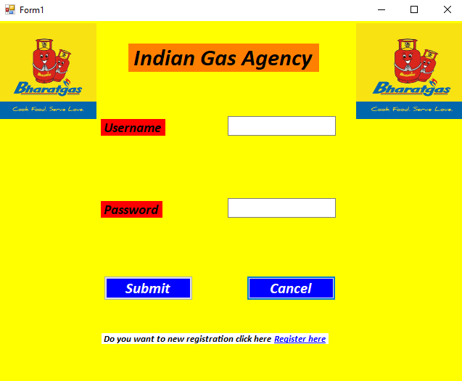

1. **Main form:-**

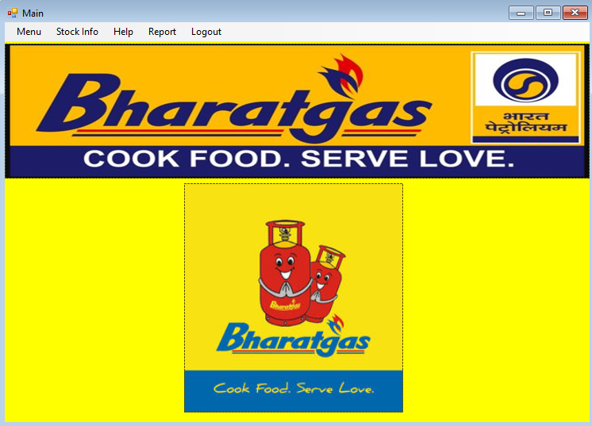

1. **Registration form:-**

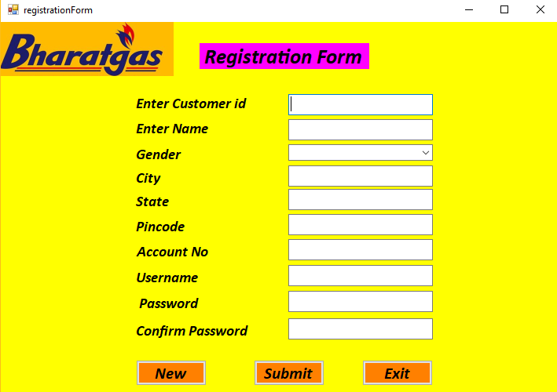

1. **Booking form:**

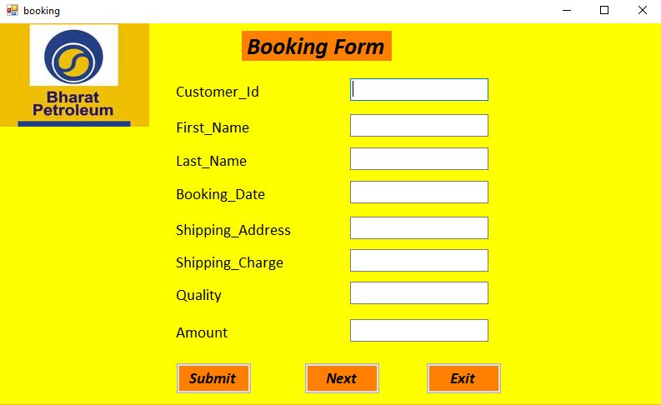

1. **Cylinder details form:-**

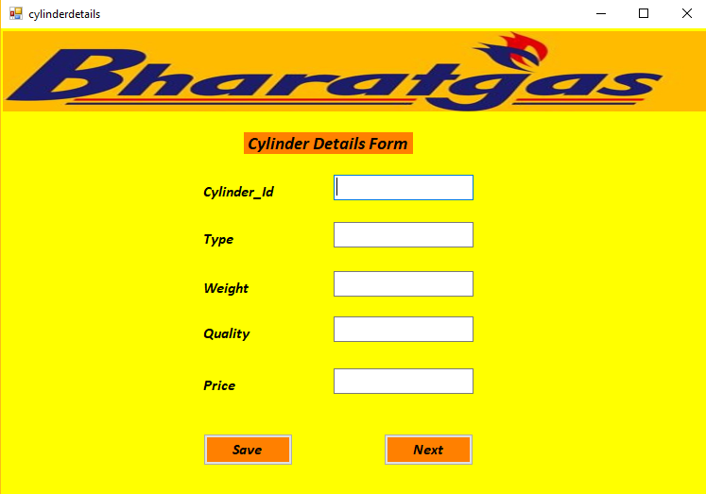

1. **Payment form:-**

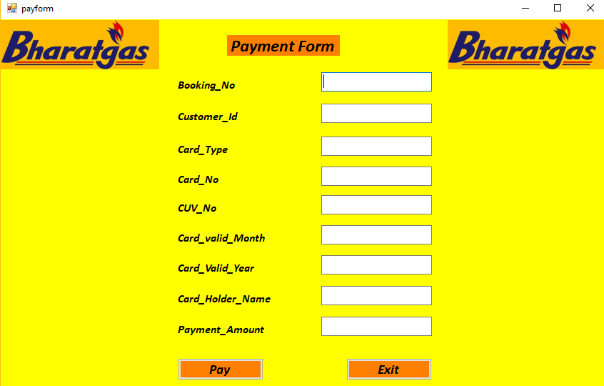

1. **Stock form:-**

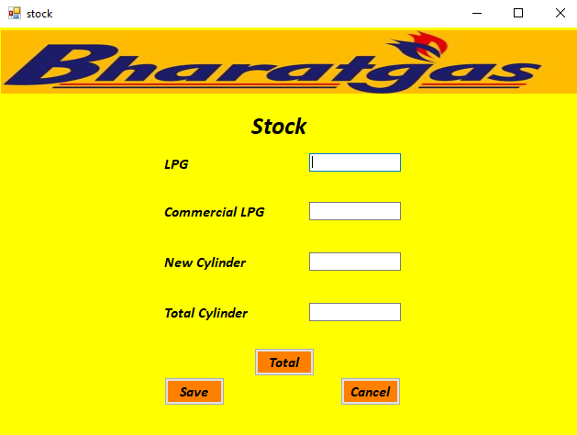

1. **Help form:-**

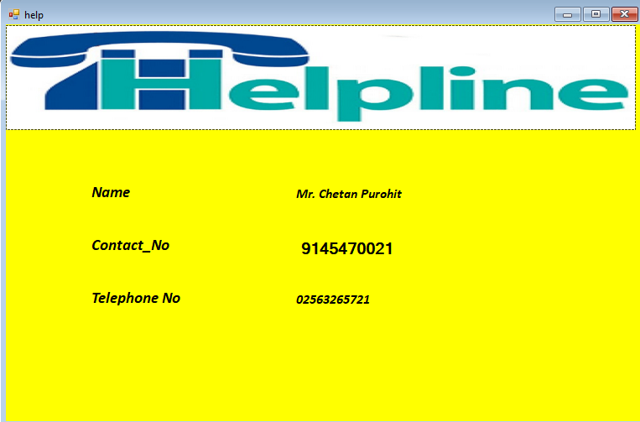

**Chapter No:-10**

**Appendix B**

1. **Register report**
2. **Cylinder detail report**
3. **Payment report**

**Crystal Report:**

1. **Register crystal report:**
2. **Stock crystal Report**
3. **Payment crystal Report**
4. **Cylinder Detail Report**
5. **Booking Crystal Report**

**Chapter No:-11**

**Conclusion**

Software qualities are reliability which includes all the new and advance facilities given by the visual basic. Software includes maintainability, modularity and good documentation making a system hundred percent reliable is nearly an impossible task, because through the testing who’s resulted in great accuracy, the online nature may create on recover which may make system accuracy, the online nature may create on recover which may make system failure still “Record maintaining” has been developed to gain reliability it its maximum extends by considering all possible kinds of problem that may occur and create error in existing system.

By using this system, we maintain records of supplier, stock, order, and purchase, sales also maintain by this system. We can generate reports of all the forms and display the information. We can find the record of supplier or stock within minimum time. As per software quality is concerned, I tried to make the system user friendly and easy to understand.

**Chapter No:-12**

**References**

1. Visual Basic:-

By: Steven holzner

Black book

1. System analysis and Design:-

By: Award E.M

Golgotha Publication.

1. Database Management System:-

By: korthSibetschutz

Tata McGraw-Hill Publication New Delhi.

1. Case in System Analysis:-

By: M.R.Anturkar

Pune Vidhyarthi Gruha Prakashan.

1. Software Engineering:-

By: Pressman R.S.